**Food As Medicine [title]**

**How food nourishes and protects your body?**

What you choose to eat has profound effects on your overall health.

[subtitle]

[Starting]

**"Food As Medicine" : term coined by Hippocrates 2500 years ago!!!!**

**[title1]**

You know your diet plays a huge role in weight and energy, and [even your mood](https://www.everydayhealth.com/wellness/united-states-of-stress/ultimate-diet-guide-stress-management/). Good nutrition and what you put into your body is the foundation for good health. “Food as Medicine” is a term which was originally coined by Hippocrates, the father of Western medicine; it was his belief that eating wholesome food is the basis for good health.  Hippocrates said almost 2500 years ago “Leave your drugs in the chemist's pot if you can heal the patient with food."

Centuries ago the earliest known doctors and health practitioners across the world imparted the benefits of using food as medicine to heal the body and now based on research it is clearly evident that food plays a major role in health and how you feel on a day to day basis.

Hippocrates believed that illness stemmed from inadequate nutrition and bad eating habits and that if people were to learn good eating habits then optimum health would be restored.  Long before doctors and medicine was commonly used, wise tribal elders would seek out healing herbs and plants for their community and food would be applied prescriptively to bring about healing.  Slowly through the years man has moved away from the healing power of nature and towards prescribing packaged synthetic drugs and artificial remedies to deal with illness.

Consequences Of usage of chemical drugs

[title 2]

The reality is that because we have shifted away from natural remedies and many of us rely on a diet of processed, fatty and sugar-laden food the consequences are that rates of obesity and disease have increased significantly.

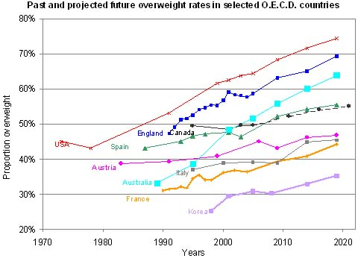

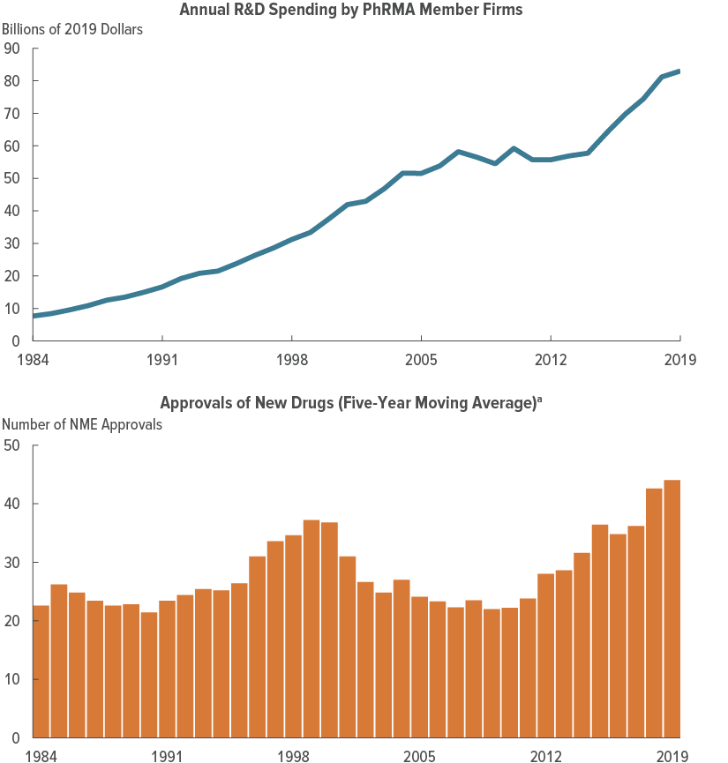

Here above you can see two graphs one of them is that of propotion of overweight and other one is of increase in purchase of medicines over the years.

If you observe both the graphs carefully you will find that both the graphs are interrelated from which we can easily conclude that there is some relation between the increase in the usage of medicines and the increase in obesity.

This is one of the many consequences which are being observed by scientists over the year that how depending too much on chemical drugs are making are life worsen.

If food has the power to prevent much of the chronic illness we experience today then it makes sense to alter our diets to use it to our own advantage to not only heal and restore the body but also to prevent illness.  Although taking pharmaceutical drugs for ailments may be useful, they often come with short and long term side effects and contribute to the toxic build up in our bodies.  While drugs are important in life threatening situations, if long term conditions can be managed with diet and lifestyle changes then using food as medicine must be considered as a initial way of tackling the issue and preventing future health problems.

Health practitioners and scientists are now uncovering the benefits of Nutrigenomics and the whole notion that food is information that speaks to our genes and triggers messages that create health or disease. There are many factors that culminate to bring about disease such as stress, nutrition, hormone balance, the health of our gut, and the importance of detoxification and food.

What it actually means to be healthy?

Being healthy means putting the right fuel into your body and having your internal engine run smoothly. Every meal that you consume influences the way that you feel one way or another so the more nutritious foods you choose, the healthier you will be. Whole foods act as medicine to heal and protect your body and give the immune system a break from dealing with toxins, preservatives, additives and chemicals that are included in so many of today's processed foods.

If you are eating junk food everyday with little or no nutrition, your body will not be receiving all of the nutrients it needs to function properly and health issues can arise. All that your body can operate on are the foods that you choose to put into it. Healthy nutrient-rich and alive foods help to heal the body at cellular level and build strong defenses enabling you to combat illness and environmental toxins.

## The Best Diet: The One That Works for You

If you bristle at the thought of complying with someone else's idea of how you should shed pounds, the good news is that you don't need weeks' worth of expensive prepared frozen meals or a militant eating and exercise program to drop the weight. Even a slight decrease in calories, preferably on a plan that meets nutritional needs, is all it takes.

"One diet is not necessarily any more successful than the next," says Joy Bauer, MS, RD, author of *Your Inner Skinny: Four Steps to Thin Forever*. "We know from research studies that almost any plan that reduces calorie intake results in weight loss, regardless of whether it's high-carbohydrate, low-carbohydrate, high in protein, or low in fat."

But here's the rub: Weight loss won't last unless you change your eating and [**exercise**](https://www.webmd.com/fitness-exercise/ss/slideshow-7-most-effective-exercises) habits for good in a way that meshes with your food preferences, schedule, and lifestyle.

## 6 Key Questions to Answer

• **Do you prefer to eat three, five, or eight meals a day?** Once you determine your desired eating schedule, divide your calories accordingly.

• **How much time will you devote to food preparation?** If you hate to cook, or have limited time, you'll need to simplify the preparation of healthy, fresh, and lightly processed foods.

• **What type of support, and how much, do you require?** Everyone needs some cheering on to succeed, especially when the initial enthusiasm for changing bad habits begins to wane. Family and friends, online weight loss communities, and diet buddies can help you when you're tempted to ditch your healthier diet and exercise program.

• **Do you love to dine out?** You'll need to account for restaurant food by seeking out the calorie counts of the foods you eat most often.

• **Will you require a daily treat to feel satisfied?** If you can't live without a little something special every day, reserve 100 calories for a single-serve package of cookies or chips, or for a frozen treat, like a fudge bar.

• **How much exercise can you reasonably do?** Experts recommend at least 30 minutes a day of moderate physical activity, such as walking, on most days of the week, but you may have to build up to that, especially if you aren't physically active. Ask your doctor what's best for you.

[bhaiya idhar aapki sahitya cha hiye idhar bhi kuch likh do lol]

Food Remedies()

Food, at its most basic level, is fuel. It powers you, giving you the oomph you need to make it through the day. But if you choose wisely, what you eat can [also be healing](https://www.womansday.com/health-fitness/a24558337/diet-changes-diabetes/). And luckily for us, science is moving in the direction of utilizing food as medicine as researchers discover more about the curative properties of [certain nutrients](https://www.womansday.com/health-fitness/advice/g1271/heart-healthy-food/). Read on to see which ingredients deserve a spot in your kitchen and find simple, delicious recipes from my new book, [*Joy's Simple Food Remedies*](https://www.amazon.com/Joys-Simple-Food-Remedies-Whatevers/dp/1401955673/?ots=1&linkCode=ogi&tag=womansday_auto-append-20&ascsubtag=%5bartid|10070.g.23508576%5bsrc|%5bch|%5blt|), that use these [therapeutic foods](https://www.womansday.com/health-fitness/nutrition/advice/a2400/5-pain-fighting-foods-117030/). Then be prepared to start feeling your best yet — your body will be happy, and you will be too!

Ease Aches and Pains: Tart Cherry Juice

Drink up! It can help calm hurting joints. Per one recent review of studies, scientists discovered that tart cherries and their juice helped lower oxidative stress and inflammation, which in turn contributed to reducing the effects of [arthritis](https://www.womansday.com/health-fitness/a60609/denise-albert-rheumeatoid-arthritis/).

Ease Aches and Pain: Ginger

Use it to feel better post-exercise: A study in The Journal of Pain found that consuming 2 g of ginger every day (about 1 tsp of fresh grated ginger root or ¼ tsp of dried ginger powder) helped relieve [muscle soreness](https://www.womansday.com/health-fitness/g22640015/best-protein-powders-women/) by 25% more than a placebo the day following a workout.

Ease Aches and Pain: Turmeric

This spice contains curcumin, which helps suppress inflammatory chemicals that contribute to joint pain. One analysis from the Journal of Medicinal Food found that a curcumin extract helped relieve discomfort from osteoarthritis as effectively as over-the-counter pain relievers.

Lift Brain Fog: Lentils

Give lentils some love! Just ½ cup of these versatile legumes provides nearly half your daily dose of folate, a B vitamin your body requires to produce neurotransmitters linked to motivation such as dopamine and serotonin. If you don't get enough folate [in your diet](https://www.womansday.com/health-fitness/nutrition/g3238/ways-to-stay-skinny/), it might be more difficult for you to focus and remember things.

Transitioning to a diet based on whole foods can improve your health in countless ways. Foods that offer particularly powerful benefits include:

* **Berries.** Numerous studies have found that nutrients and plant compounds in berries combat disease. In fact, diets rich in [berries](https://www.healthline.com/nutrition/8-healthy-berries) may protect against chronic conditions, including certain cancers ([40Trusted Source](https://www.ncbi.nlm.nih.gov/pmc/articles/PMC5187535/)).
* **Cruciferous vegetables.**Cruciferous vegetables like broccoli and kale contain a wide array of antioxidants. High intake of these vegetables may decrease your risk of heart disease and promote longevity ([41Trusted Source](https://www.ncbi.nlm.nih.gov/pubmed/21593509)).
* **Fatty fish.** Salmon, sardines, and other fatty fish fight inflammation due to their high levels of omega-3 fatty acids, which also protect against heart disease ([42Trusted Source](https://www.ncbi.nlm.nih.gov/pmc/articles/PMC6073188/)).
* **Mushrooms.** Compounds in mushrooms, types of which include maitake and reishi, have been shown to boost your immune system, heart, and brain ([43Trusted Source](https://www.ncbi.nlm.nih.gov/pmc/articles/PMC4320875/)).
* **Spices.** Turmeric, ginger, cinnamon, and other spices are packed with beneficial plant compounds. For example, studies note that [turmeric](https://www.healthline.com/nutrition/top-10-evidence-based-health-benefits-of-turmeric) helps treat arthritis and metabolic syndrome ([44Trusted Source](https://www.ncbi.nlm.nih.gov/pmc/articles/PMC5618098/), [45Trusted Source](https://www.ncbi.nlm.nih.gov/pmc/articles/PMC5664031/)).
* **Herbs.** Herbs like parsley, oregano, rosemary, and sage not only provide natural flavor to dishes but also boast many health-promoting compounds ([44Trusted Source](https://www.ncbi.nlm.nih.gov/pmc/articles/PMC5618098/)).

**Green tea.** Green tea has been thoroughly researched for its impressive benefits, which may include reduced inflammation and lower disease risk ([46](https://www.ncbi.nlm.nih.gov/pubmed/20370896)

## The bottom line

Food does much more than simply provide you with fuel. It may promote or worsen health, depending on what you eat.

A nutrient-dense diet of [whole foods](https://www.healthline.com/nutrition/21-reasons-to-eat-real-food) has been shown to prevent many chronic diseases and may help treat some conditions, such as type 2 diabetes.

Although it’s clear that following a [nutritious diet](https://www.healthline.com/nutrition/healthy-eating-for-beginners) is one of the most important factors in living a long, healthy life, keep in mind that you should not rely on food to replace conventional medicine.

The most important dietary changes you can make, almost no matter what your

0:12

health condition is, is to increase your intake of fruits and vegetables. We know

0:16

that fruits and vegetables help prevent cardiovascular disease, prevent obesity,

0:22

prevent diabetes, prevent many types of cancer, and so as a health professional

0:30

we always advocate for healthy diets. Healthcare providers across the United

0:37

States are becoming increasingly aware of how important food insecurity is for

0:41

their patients, and there are a lot of ways in which your healthcare provider

0:45

may be able to support you if you're able to bring these issues into a

0:50

conversation with them, and then there may be resources in your community and

0:54

in this very hospital. Social workers can help connect you to benefits and find

0:59

local food pantries that get food from the food bank. There are community

1:04

programs for which you may be eligible and the social worker can help connect

1:08

you to those. And if you're in the fortunate position of not needing these

1:13

services, then there are many, many nonprofits in these communities that are

1:17

supporting people who are food insecure with healthy food every day, and those

1:21

are organizations that you should consider supporting.

1:33

We have chard and kale in our far bed. We planted that on our opening day:

1:39

August first, and those plants will actually survive all winter and we'll be

1:45

harvesting about every week or every two weeks from those beds. And then we also

1:52

have some carrots and beets that are coming up pretty soon, so this is just

1:56

one hoop house out of three that we have in production this winter. We manage the

2:01

food pantry at the St. Michael Catholic Church, and we're affiliated with the Food

2:08

Bank of Northern Nevada. Because we're distributing every week, so we're

2:13

feeding around 80 to 90 families, and these are for the

2:19

people that has diabetes and have a high blood pressure and, yeah we're happy that

2:26

this program is also is also helping us out.